Nama : Muhammad Arif Rivai

NPM : 21312097

Kelas : IF 21 B

Hasil Screenshot

1. IMPLEMENTATION OF DOUBLY LINKED LIST

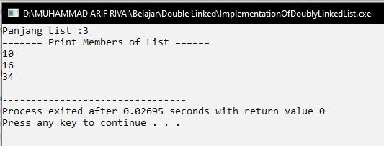

1. IMPLEMENTATION OF DOUBLY LINKED LIST (FUNCTION)

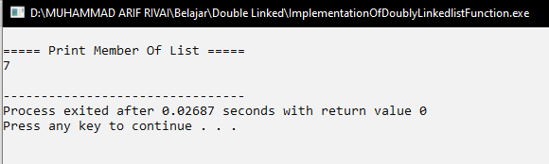

1. IMPLEMENTATION OF INSERTING A NEW NODE AT THE BEGINNING

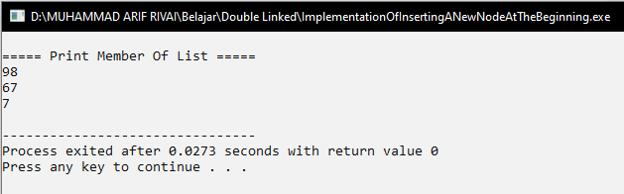

1. IMPLEMENTATION OF INSERTING A NEW NODE AT THE ENDING

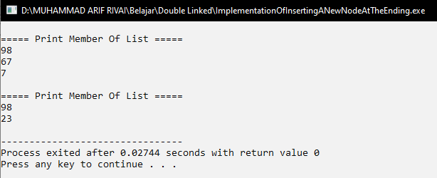

1. IMPLEMENTATION OF DELETING THE FIRST NODE

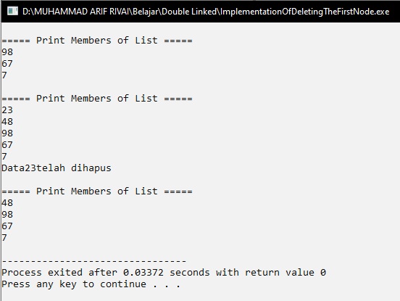

1. IMPLEMENTATION OF DELETING THE LAST NODE

